
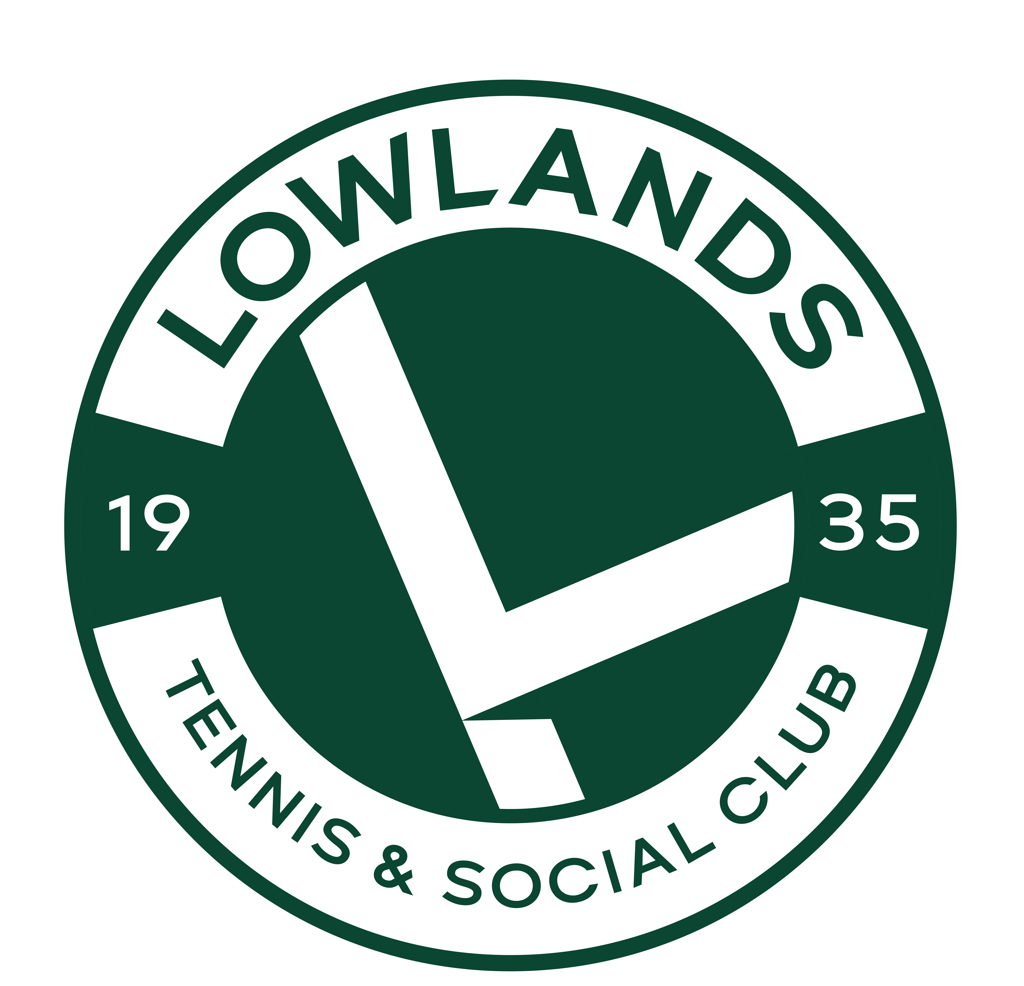

Lowlands Road, Eastcote, Middlesex HA5 1TU www.lowlandsclub.com

Competition Standard Junior Member - £85 a year
Up to 18yrs (Under 19 on 01/03/2026)
- Use of full-size courts including use of floodlights. (some restrictions apply, see court schedule)
- Discount on group and individual coaching
Junior Tennis Membership Form
1st March 2026 – 28th Feb 2027

Junior Member - £57 per year
Up to 18 yrs (Under 19yrs on 1/03/2026)
- Use of mini court only (supervision required for members under 11yrs)
- Discount on group and individual coaching

If you have any questions, regarding coaching please do not hesitate to contact Head Coach Simon Gibaut on
07764 501117 or simon@sgtennis.co.uk
Alternatively, if you need more information about membership or payment, please contact the Membership Secretary at info@lowlandsclub.com
Please fill out the form below and return to Lowlands Club. Forms may be returned electronically to info@lowlandsclub.com or be placed in the post box at the club (left hand side of the front door).
- Under supervision, members 11yrs and over may use the clubhouse until 9pm every night which includes darts, pool, tv. Snacks and drinks can be purchased from the bar.
- FREE pool on Wednesday and Friday until 9pm for members attending that evening coaching session.
- Club tournament organised for players of a suitable standard
- Entry into Wimbledon ticket ballot (must be at least 11yrs old; a BTM member and have ‘opted in’ to the ballot on the LTA website)

1st Child’s Name: |  |  | Click or tap here to enter text. |  |  |  |  | Male: | ☐ | Female: |  | ☐ | Date of Birth: | Click or tap here to enter text.
Any Medical Conditions: |  |  |  | Click or tap here to enter text.
2nd Child’s Name: |  |  | Click or tap here to enter text. |  |  |  |  | Male: | ☐ | Female: |  | ☐ | Date of Birth: | Click or tap here to enter text.
Any Medical Conditions: |  |  |  | Click or tap here to enter text.
Parents Name: | Click or tap here to enter text.
Address: | Click or tap here to enter text.
Postcode: | Click or tap here to enter text. |  |  |  |  |  | Contact Number: |  |  |  | Click or tap here to enter text.
Email Address: (please write legibly) |  |  |  |  |  | Click or tap here to enter text.
Signature of Parent:
By signing below I agree to:
- Become a member of Lowlands Tennis Club and abide by the club rules.
- Become a BTM member (FREE to sign up LTA website www.LTA.org.uk/BTMTC) and agree that you/your child will abide by the terms and conditions of British Tennis Membership.
- I agree that the Club can use my personal data (name, address, phone number and e-mail) for membership purposes. See website – www.lowlandsclub.com for the full Privacy Policy.
- Lowlands Tennis Club recognises its moral and statutory responsibility to safeguard and promote the welfare of all children. I agree to read and accept the relevant policies contained on our website.

